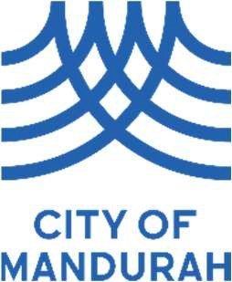
Annual Electors’ General Meeting
Elector’s Question Form

Contact details

Name
Address
Contact Number
Email Address

Electors* are welcome to submit a question to the Annual Electors’ General Meeting relating to the annual report or any other general business.

This form enables questions to be submitted. By submitting written questions in advance of the meeting it allows for the matter to be investigated and answers to be prepared in detail. Please consider whether your question would be better explained to you personally or at the Annual Electors’ Meeting.

* An Elector may be one of the following —
- a resident owner or occupier enrolled to vote at State elections;
- an owner of rateable property (e.g. an absentee landowner or an owner of business premises, vacant land, or other non-residential property);
- an occupier of rateable property (e.g. a tenant of business premises or other non-residential property).

Question details

Provide your question below
Please note that up to three questions may be submitted.
Will you be in attendance to ask your question in person?

☐ | Yes | ☐ | No

If you would like to authorise another person to ask on your behalf, please
provide their name.

This form can be completed and returned to the Governance Team by 12pm Friday 6 February 2026, by emailing to minute-officer@mandurah.wa.gov.au or hand delivering to the City Administration office located on 3 Peel Street Mandurah WA 6210.
Please ensure that you bring ID with you to the meeting to confirm your elector status.

