City of Mandurah MARC
Accessibility Access
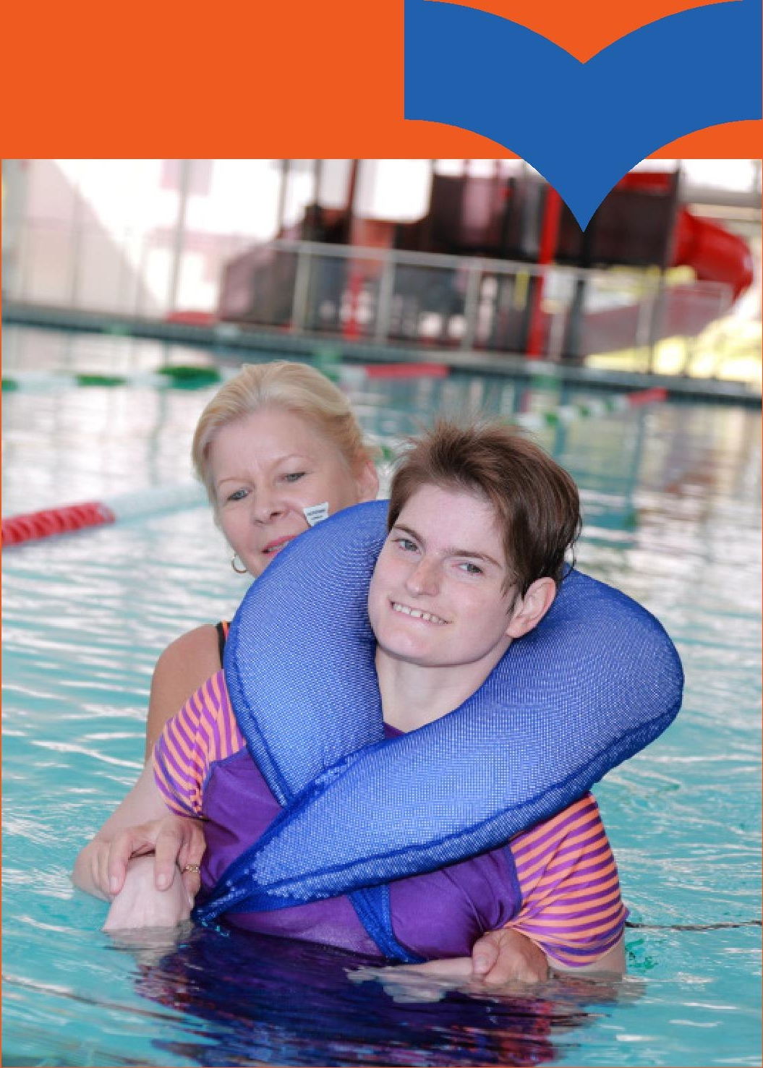

Mandurah Aquatic and Recreation Centre
Phone: 9550 3600
Address: 303 Pinjarra Road, Mandurah
Email: recreationcentres@mandurah.wa.gov.au
To learn more information about accessible features at the MARC or around the City of Mandurah, scan the code below:
City of Mandurah website: mandurah.wa.gov.au

Aquatics
- Lifeguards always on duty during opening hours
- Wheelchair access to every pool indoor/outdoor
- Easy stair access to every pool indoor/outdoor
- Hand rails in pool walking lanes
- Pelican hoist (200kg limit) for use on any pool
- Perfect egress to every pool
- Handrails at entry and exit to pools – non-slip
- Gradual entry to beach pool
- Hoist for spa
- 7 x family and accessible change rooms – lowered toilet, basin, rails, non-slip tiles, spacious
- 1 x adult change facility with bed and hoist (230kg limit) – Changing places facility (no MLAK key required)
- 4 x aquatic chairs
- Separate change rooms for swim schools

Fitness
- Staff always available to assist
- Stickers to identify universal access on gym equipment
- Universal access equipment including
  - 2 x arm rowers
  - Low row
  - Shoulder press
  - Chest press
  - 2 x adjustable pully system
  - Free weights
  - Pull up bars
  - Wheelchair basketball and badminton
  - A range of inclusive gym classes available

Centre
- 12 x ACROD parking bays with overflow parking with ACROD bays across the road
- Accessible changerooms and toilets
- Drop off and pick up area
- First aid wheel chair located at reception
- Creche
- Accessible (flush) entry ways throughout centre (with the exception of the squash courts)
- Wheelchair seating spaces in stadium courts
- Quiet times – enquire at reception
- Noise reduction headphones available at reception
- Companion Card (Free entry) – to be presented at reception

Cafe
- Free Wi-Fi
- Alfresco seating
- 7 days per week

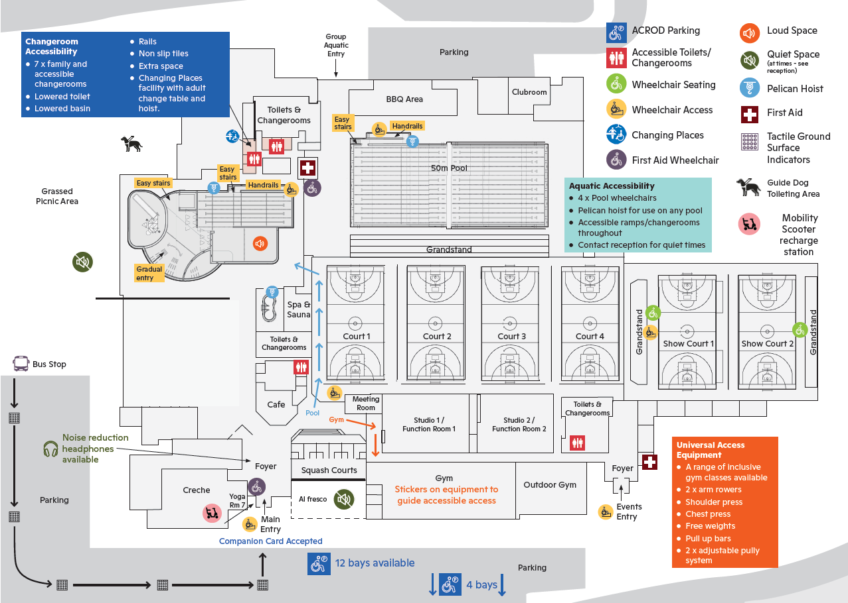

Map of MARC
The diagram above is a map of Mandurah Aquatic and Recreation Centre (MARC), which is explained in more detail below.

Bus stop and parking
There is a bus stop near the car park outside the MARC.
- Bus routes that run along or within 200 metres of the MARC include bus number 588, 591, 592, 593, 594 and 600.
- To plan your journey to the MARC using public transport, please visit the Transperth JourneyPlanner: www.transperth.wa.gov.au/Journey-Planner
From the bus stop, go forwards through the car park and turn left around the corner to reach the front of the MARC building. Tactile Ground Surface Indicators help guide you from the bus stop to the main entry point.
There are 12 ACROD parking bays at the front of the building and a further 4 ACROD parking bays further away from the main entrance.

Main entry and foyer
Enter the MARC via the main entry at the front of the building on Cemetery Road. Wheelchair ramp access is available. There is a mobility scooter recharge station to your left near the main entry.
When you enter the MARC, there is a First Aid wheelchair and noise reduction headphones available from reception in the main foyer. Companion Cards are accepted.
To your left as you enter is Yoga Room 7 and the Creche.
To your right as you enter is café seating and through the doors is the al fresco area, which is a designated quiet space at certain times. See reception for more information.
As you move forward towards the gym entry there are accessible bathrooms available to the right hand side of the café down a short corridor.

Gym
Turn right from the foyer. You will come to an intersection. The café is on your left and the squash courts are on your right, with the foyer behind you.
As you head down the right-hand side, past the squash courts, there is a meeting room on your left. An entry gate and turnstile will be in front of you; use your FOB key on the scanner or ask reception to open the gate. Turn right down this corridor to enter the gym.
In the gym, there are stickers on the equipment, in the form of a wheelchair graphic, to identify the universally accessible equipment. The gym also also connects to an outdoor gym.

Universally Accessible Equipment
- A range of inclusive gym classes available
- 2 x arm rowers
- Shoulder press
- Chest press
- Free weights
- Pull up bars
- 2 x adjustable pully system

Outdoor gym
Head back out of the gym and continue right down the corridor. There are two studio/function rooms on your left. Further along this corridor, there are toilets and changerooms, including an accessible toilet.
At the end of this corridor, turn right to enter the outdoor gym.
Turn back down the corridor, past the toilets and changerooms and the studio rooms, and back out the turnstile/gate until you reach the café/intersection.

Basketball courts
At the café intersection, turn and walk through the open doors to basketball courts 1-4.
The café will be on your left. Continue walking through the doors and down the corridor. The two studio/function rooms and the toilets and changerooms are now on your right. On the opposite side of the corridor, there are four multipurpose indoor courts on your left.

Indoor pool
From the main foyer, the café is on your left and the squash courts are on your right, with the foyer behind you.
Go through the open doors; the basketball courts are to your right. Continue down this corridor and turn left. Entry to the spa and sauna are on your left. There is a Pelican Hoist available in the spa and sauna.
Directly in front of the spa and sauna is a leisure pool connected to a 25-metre lane pool. This pool is a designated loud space. A Pelican Hoist is available for the pool.
There is a gradual entry point and easy stairs into the leisure pool. There are easy stairs, handrails and wheelchair access into the lane pool.
Outside the leisure and lane pool is a guide dog toileting area and grassed picnic area. This is a designated quiet space at certain times. See reception for more information. First Aid and Headphones are also available at the Aquatics office located next to the green change pods. The green change pods are available to use as a sensory calming space; see the Aquatics office.
Accessible toilets/changerooms and a Changing Places facility are available in the leisure/lane pool area, on the same side as the handrails and ramp that provide access to the lane pool behind the green change pods.

Changeroom Accessibility
- 7 x family and accessible changerooms
- Lowered toilet
- Lowered basin
- Rails
- Non slip tiles
- Extra space
- Changing Places facility with adult change table and hoist
The toilets and changerooms also connect the indoor pool to the outside pool area. See “Outdoor pool” section for more information.

Outdoor pool
As you enter outside from the indoor pool area, there is a BBQ area on your left and the 25/50-metre pool will be in front of you. The toilets and changerooms, which can be accessed from the indoor pool, are now behind you. The grandstand overlooking the pool will be on your right.
Wheelchair access ramp, easy stairs and handrails provide access to the 50-metre pool which will be in the left-hand corner.
Following the path down the left-hand side of the pool will take you past the outdoor BBQ area to the club rooms on your left.

Aquatic Accessibility
- 4 x Pool wheelchairs
- Moveable Pelican hoist for use on any pool
- Accessible ramps/changerooms throughout
- Contact reception for quiet times

Events
The events entry point is on the opposite side of the building to the group aquatic entry. It is on the same side of the building as the main entry, but further along to your right, past the car park. There is a flush entry
As you enter the events foyer, there are several rooms to your right and First Aid facilities.
Turn right to enter the grandstand overlooking a multipurpose court, labelled Show Court 1 on the map. The Show Court 1 grandstand has wheelchair seating spaces.
Next to Show Court 1 is Show Court 2 with another grandstand which overlooks Show Court 2.

